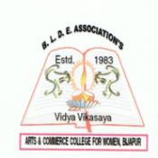
BLDE Association’s
Smt. Bangaramma Sajjan Arts, Commerce and Science College for Women, Vijayapur – 586101

Department of Hindustani Music
The Activities conducted during the Academic Year 2021-22
Sl.No. | Date | Event
 | 17.09.2022 | Annual Social Gathering and Felicitation to the Meritorious Students.
 | 01.11. 2021 | Celebration of Karnataka Rajyotsava
 | 26.01.2022 | Celebration of Republic Day
 | 08.02.2022 | Celebration of Subhash Chandra Bose Jayanti
 | 08.03.2022 | Celebration of International Women’s Day
 | 18.07.2022 | Ted- Talk
 | 14.08.2022 | Azadi Ka Amrit Mahotsava, Har GharTiranga Abhiyan held at SS campus by holding 900 meter National Flag
 | 15.08.2022 | Celebration of Independence Day
 | 30.08.2022 | Farewell for Final Year Students and Annual Social Gathering
 | 06.09.2022 | Vachana GayanaSamavesh held at Karnataka State Akkamahadevi Women’s University.

